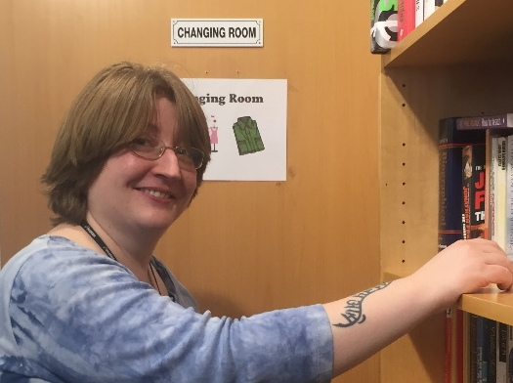
Beth started volunteering with us as a skills and employment adviser for companions, but has since helped us out by supporting other volunteers, organising events for us, and more.
Why did you choose to volunteer for us?
I am qualified in careers guidance but haven’t had the opportunity to use that training in my own career. My passion is for helping people to realise their potential, and working with the companions means I can be a useful addition to what the support team already does here.
I like how informal and friendly the environment is here – I knew I didn’t want to push people or have to hit targets that weren’t meaningful to them, and Emmaus gives companions the space they need to work out their own priorities in an unpressured environment. I can work with people as and when they need support or guidance.
What kind of things do you do at Emmaus Bristol?
I do a lot of problem solving. Every week is different – often I’m a sounding board for companions – sometimes just talking about something helps them clarify what steps they want to take next. I do research for people to help them find out what their options are. I also do practical things like helping to write CVs, and publishing a weekly opportunities bulletin that goes to the whole community.
What ELSE do you do?
Supporting other volunteers – some can be a bit underconfident about their skills so a lot of my time is spent encouraging them in what they’re doing and building their confidence back up. This fits in well with what I do at Emmaus because rebuilding confidence is also one of the main things we do with companions. I’ve been generally helping out with events and in the warehouse, and I am currently planning my first fundraiser.
What would you want to do after Emmaus Bristol?
The variety of experience I get here will stand me in good stead for whatever comes next. I am making new contacts and doing things that used to be outside my own comfort zone. There is a willingness to try new things here, which means my ideas and input are valued, and this increases my own confidence.
What have you gained from volunteering here?
Working here has helped me recognise my own skills, and builds my self-esteem. It’s good for me to have this focus, a reason to leave the house and talk to people. This is a very good place for people who are prepared to take the initiative and go after new opportunities, and great for people who want to make a real difference to others.

